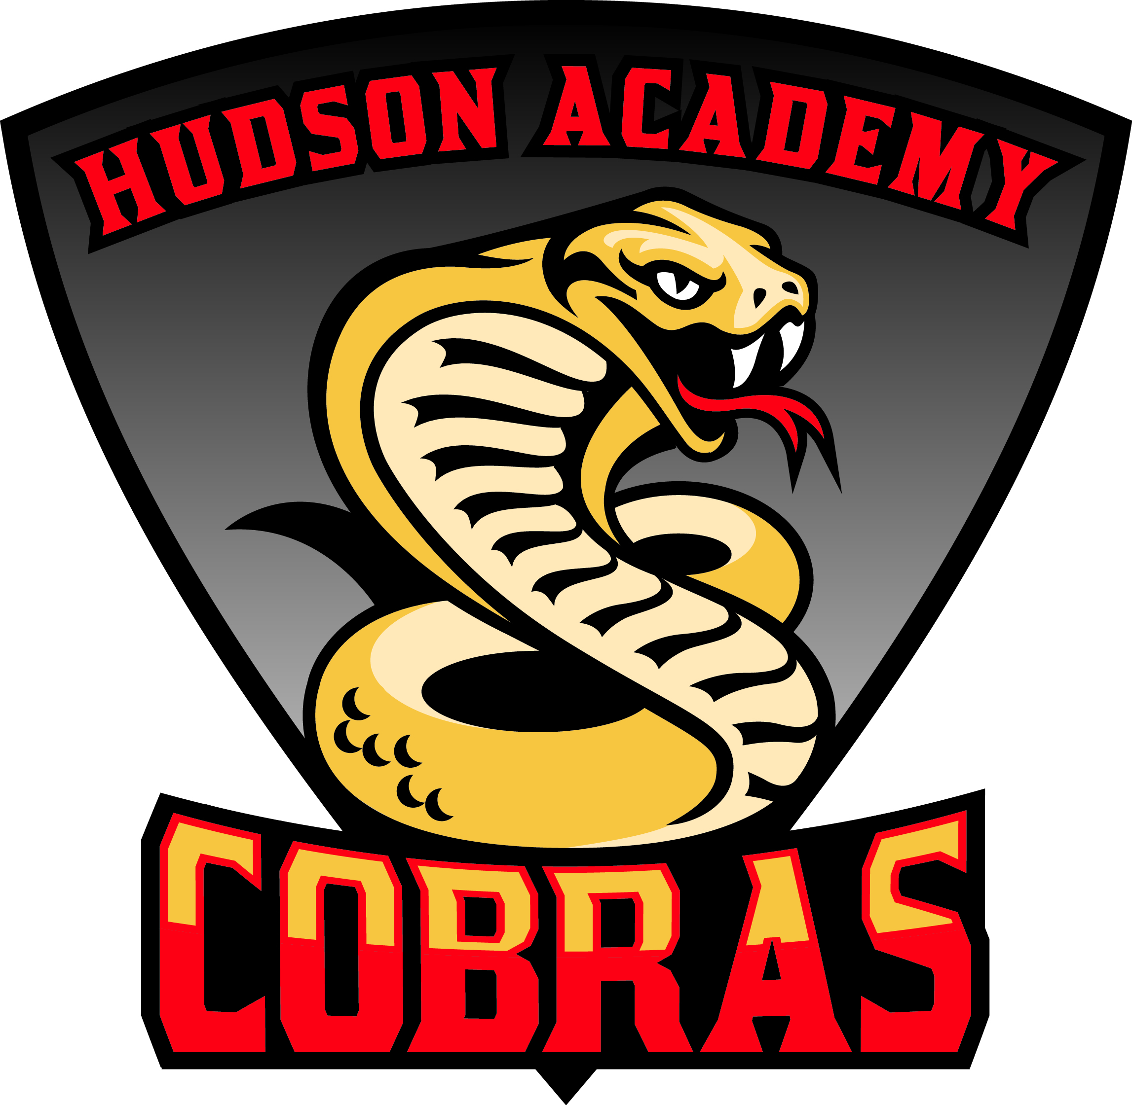
Student Name______________________________

Student Number____________________________

Class of 2033 ~ 6th Grade
Welcome to the 2026-2027 School Year. The information below is for students and parents to provide input for student schedules. Students will use this information to choose their elective courses.
Required Courses-Core course selections will be determined using FAST PM3 Data  - Cambridge English 1 (1.0)  - Math 1, Cambridge Math 1, or Cambridge Math 2 (1.0)**  - Science 1 or Cambridge Sci 1(1.0)  - Adv. US History &  Global Pers. (1.0)  - PE (.5)*  - Health & Career Planning (.5)  **Cambridge Math 1 is a prerequisite to Cambridge Math 2 | Student T-Shirt Size-Check One  _____Adult Sm  _____Adult Md  _____Adult Lg  _____Adult XL | Chose Your Electives!  All students will be placed in one semester of Health and one semester of PE-Fitness, unless the waivers are signed on the back.  Put a number 1 next to your TOP choice.  Put a number 2 next to your next choice.  Put a 3 and 4 next to back up choices:  _____ Health/PE  _____ Health/Intro to Agriscience  _____ Health/Digital Discoveries 1  _____ Health/Intro to Drama  _____ Intro to Drama/PE  _____ Intro to Drama/Intro to Agriscience  _____ Intro to Drama/Computer Science  _____ Intro and Orientation to Agriscience  _____Digital Discoveries 1 and Cyber Security  _____AVID  _____Band 1  _____Chorus  _____ Theatre  _____ Pre-AICE Spanish 1*** ______ ELA teacher recommendation
Semester Elective Classes*  Intro to Drama  Digital Discoveries 1  Cyber Security  Intro/Orientation to Agriscience  PE/Health  Year-Long Elective Classes  AVID  Band 1  Chorus  Theatre  Pre-AICE Spanish 1***  ***Requires Teacher’s Recommendation | PE WAIVER STATEMENT  PE Waiver Requirement: Senate Bill 610 requires the equivalent of one class period per day of Physical Education for one semester each year for students in grades 6-8. A waiver is required for students for the following criteria:  - Student requires a remedial course  - Parent requests another offered course  - Parent verifies that student participates in equivalent activities outside the school day  I have read the PE Waiver Statement and reviewed and approved my child’s elective course selections.  Parent Signature _______________________Date____________________
Please note that electives are scheduled based on availability. While we will try to give your child one of the their first choices, it may not be possible.
Double Advanced Cambridge Math 2 Agreement

Hudson Academy has the option to offer a double accelerated math curriculum in grades 6-8 through a partnership with Pasco eSchool. The option is available to students that accel greatly in math and are interested in taking 6th grade accelerated math through Pasco eSchool starting in April.

If you are interested in learning more about this option, please attend our Parent Preview Academy on February 26th at 6PM OR sign below and list your phone number for us to contact you.
Parent Name: _______________________Number:_________________

Band 1-Student will learn instrumental technique, music literacy, and aesthetic response through rehearsal, performance, and study of a variety of high-quality band literature.
AVID-Advancement Via Individual Determination prepares students for college readiness. Curriculum focuses on writing, inquiry, collaboration, organization, and reading.
Pre-AICE Spanish 1-The student will develop communicative skills in all 3 modes of communication and cross-cultural understanding. This is high school credit course. Spanish 1 and 2 meet the requirements for Bright Futures when both years are taken. Must have 4 or 5 of ELA FAST and ELA Teacher Recommendation
Theater- Students learn the basics of building a character through such activities as pantomime, improvisation, and effective speaking using articulation, projection, and breathing. Students also learn the importance of technical theater and explore the use of such elements as costumes, props, and scenery. Students practice writing for the theater and explore various theater roles and functions. Public performances may serve as a culmination of specific instructional goals.
Digital Discoveries 1 and Cyber Security-Students explore the foundations of coding for web design, games, cyber security, and career options.
Intro and Orientation Agriculture-Provides students with the opportunity to explore various aspects of the agriculture industry, such as plant science, animal science, and agribusiness. Industry certification is available for students who complete both courses in the same year.

Middle School Promotion Requirements
Middle school students are required to successfully complete three years of language arts, mathematics, science and social studies, take the Civics EOC, and complete the Career Planning requirement.

Intensive Coursework
- Students may be placed in an intensive reading class if they do not show proficiency on the FSA ELA Assessment.
- Students who do not receive passing grades in their four core content classes (Math, ELA, Science and Social Studies) will be placed in the academic learning lab for course recovery.

Schedule Changes
Schedule changes will not be possible once enrolled due to class-size mandates and end-of-course requirements.

Cambridge Programme for Advanced Course Work

At Hudson Academy, we offer Cambridge ELA and Social Studies curriculum to all students, in addition to the Florida Best Standards. Enrollment in our Cambridge Programme also gives students the opportunity to accelerate in math and science to earn high school credit while in middle school.

Families MUST apply to be accepted into the Cambridge Programme through Pasco Pathways School Choice. There will be an window open in April and June for those that have not previously applied. For more information, please scan the QR code and an administrator will follow up with you.



