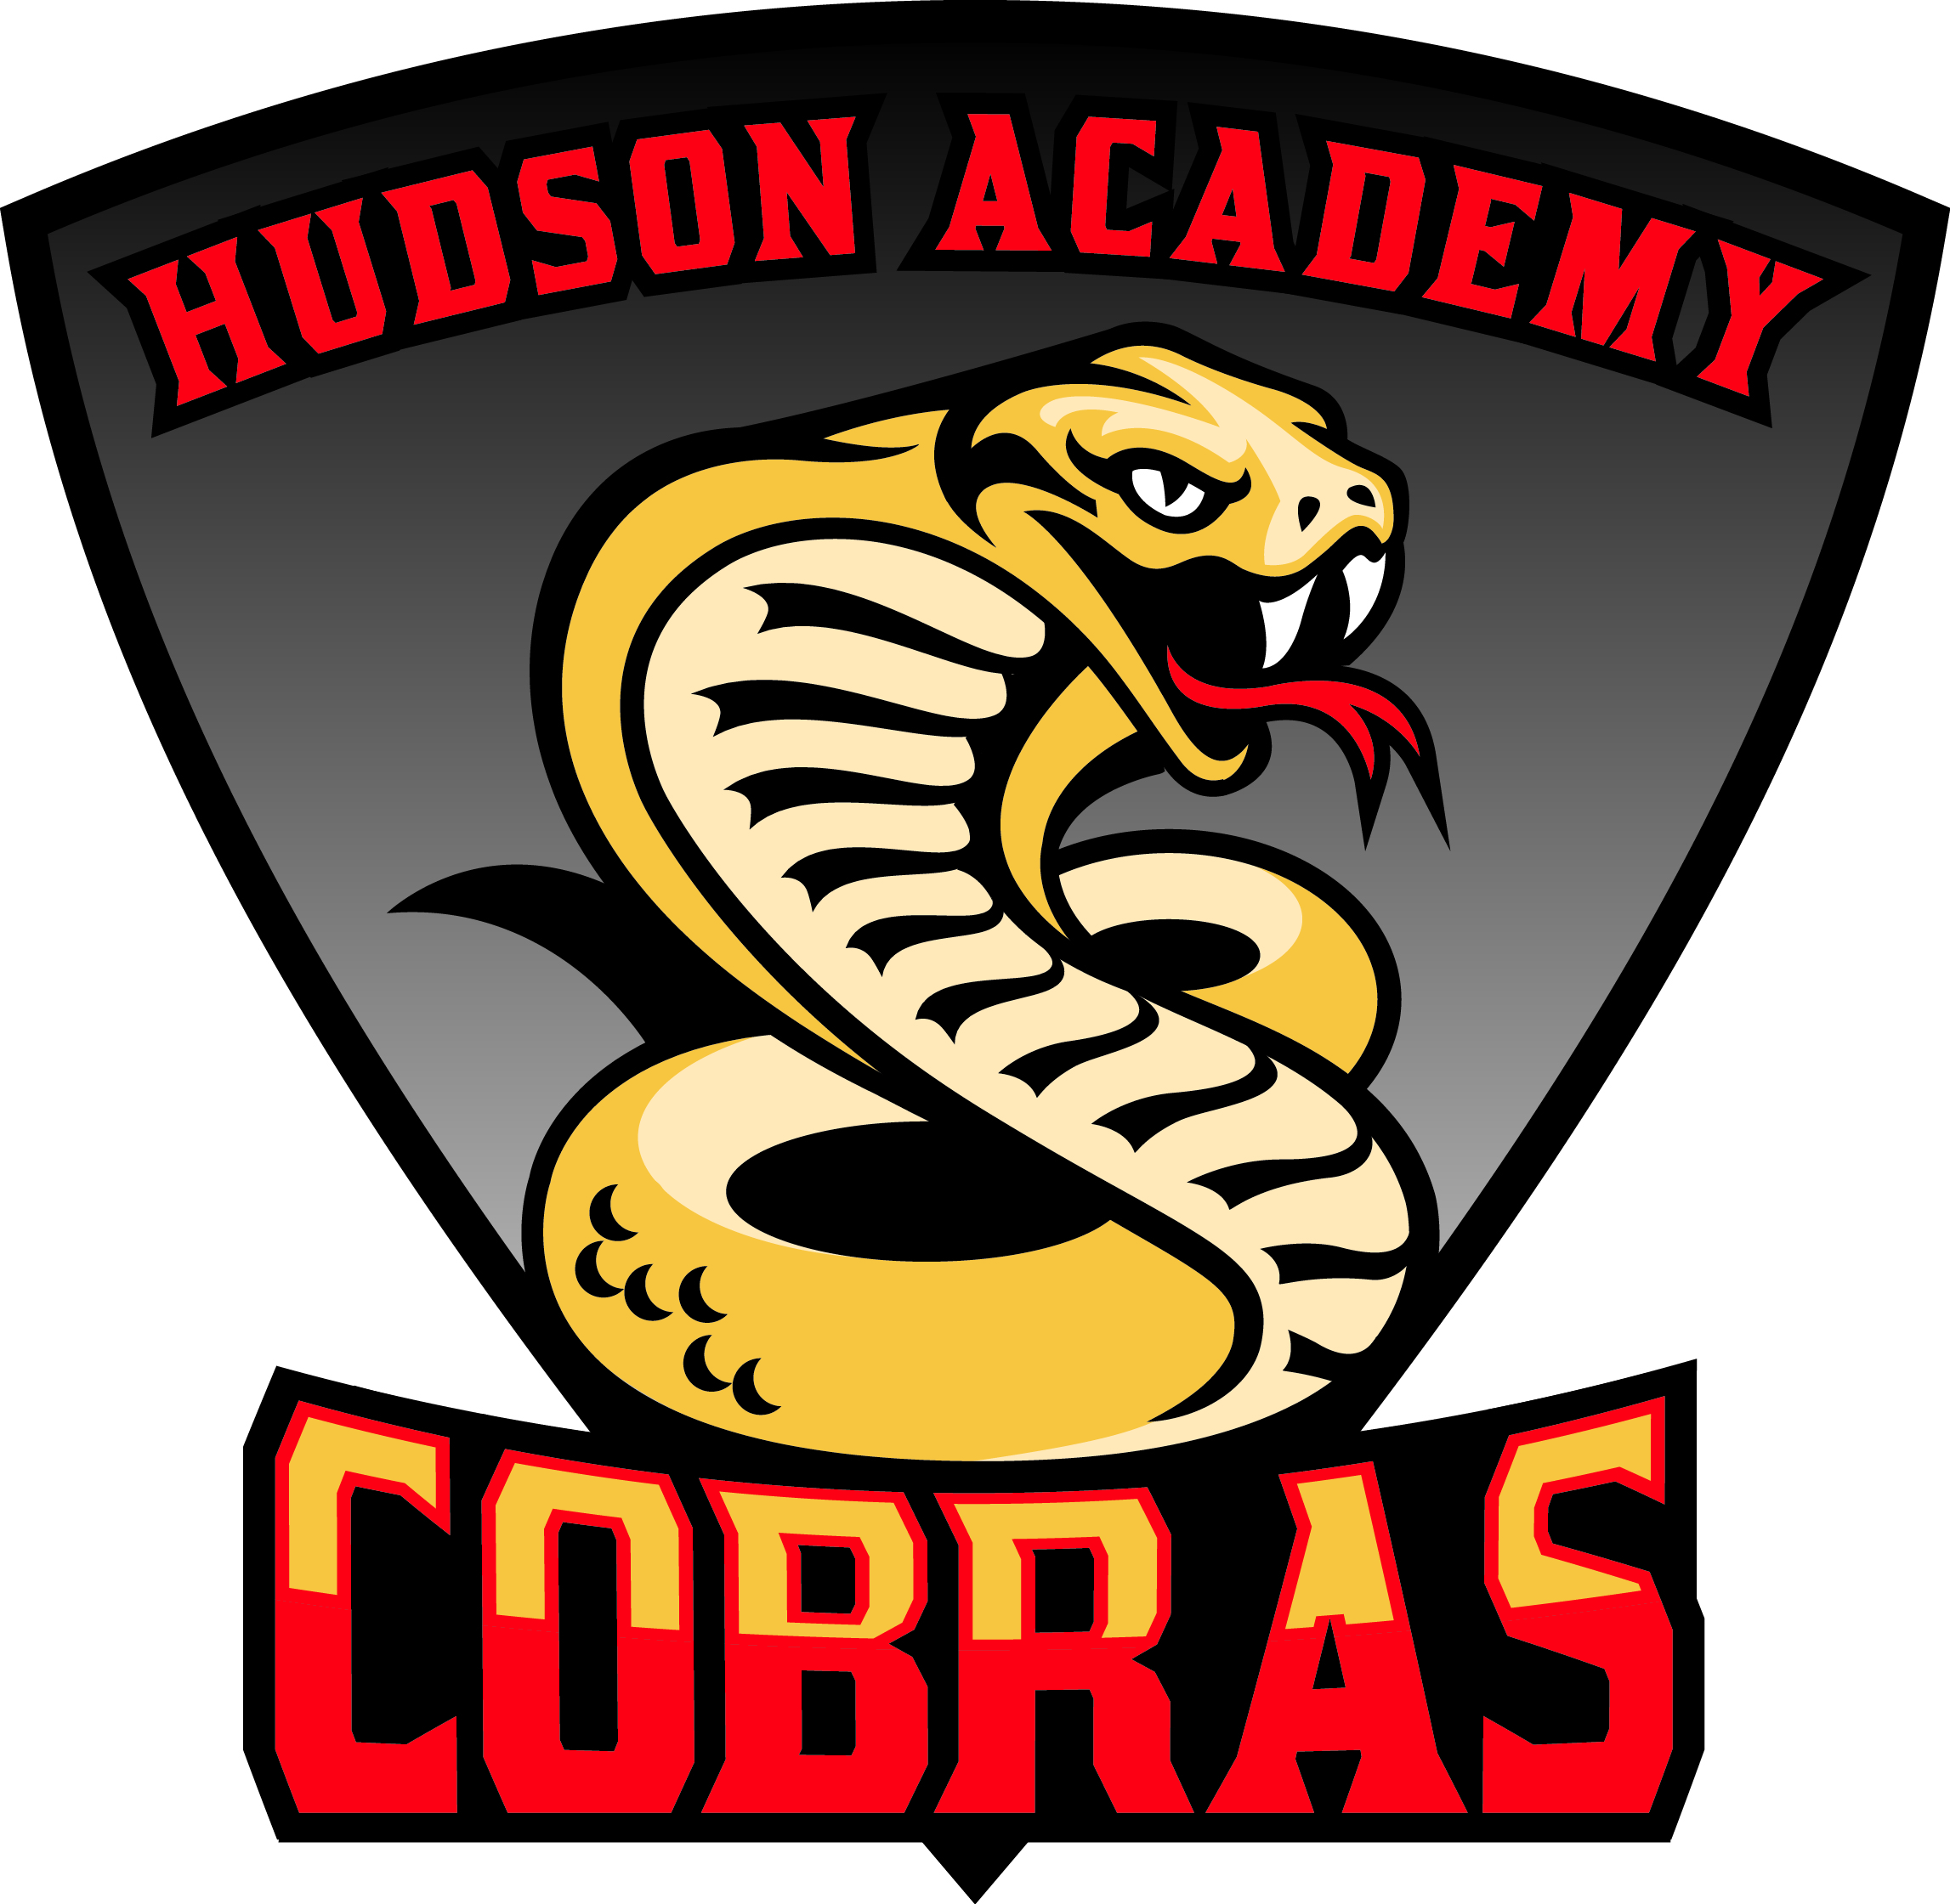
Student Name______________________________

Student Number____________________________

Class of 2031 ~ 8th Grade
Welcome to the 2026-2027 School Year. The information below is for students and parents to provide input for student schedules. Students will use this information to choose their elective courses.
Required Courses Core course selections will be determined using FAST PM3 Data  - Cambridge English 3 (1.0)  - Pre-Algebra or Pre-AICE Cambridge Alg 1 Honors or Pre-AICE Cambridge Geometry Honors (1.0)  - Science 3 or Pre-AICE Environmental Management (1.0)  - World History or Pre-AP WH & Geo (1.0)  - PE (.5)*** | High School Credit Elective Classes  Discovering Computer Science*  Pre-AICE Spanish 1*  Pre-AICE Spanish 2*  Agriscience Foundations 1*  Pre-AICE Theatre*  *Courses with * require teacher recommendation signatures | Chose Your Electives!  Put a number 1 next to your TOP choice.  Put a number 2 next to your next choice.  Put a 3 and 4 next to back up choices:  Please note that electives are scheduled based on availability. While we will try to give your child one of the their first choices, it may not be possible.  _____Discovering Computer Science* (HS)  _____Pre-AICE Spanish 1* (HS)  _____Pre-AICE Spanish 2* (HS)  _____Agriscience Foundations 1* (HS)  _____Pre-AICE Theatre* (HS)  _____Band 1  _____Band 2*  _____Band 3*  _____Chorus  _____ Instr. Ensemble - Jazz Band*  _____ AVID  _____Theatre 1 (yearlong)  _____Theatre 2 (yearlong)  _____PE (yearlong)  _____Digital Discoveries 3/Cyber Security (yearlong)  _____Intro/Orientation to Agriculture (yearlong)  _____Computers/Agriculture (semester each)  _____Computers/PE (semester each)  _____Intro to Drama/Agriculture (semester each)  _____Intro to Drama/Computers (semester each)  _____Intro to Drama/PE (semester each)
Yearlong Elective Classes  Band 1  Band 2*  Band 3*  Chorus  Instr. Ensemble - Jazz Band*  AVID  Theatre 1  Theatre 2  Semester Elective Classes  Intro to Drama  Digital Discoveries 3  Intro to Cypersecurity  Intro to Agriscience  Explorations of Agriscience  Comprehensive PE 7/8  Individual Sports | PE WAIVER STATEMENT  PE Waiver Requirement: Senate Bill 610 requires the equivalent of one class period per day of Physical Education for one semester each year for students in grades 6-8. A waiver is required for students for the following criteria:  - Student requires a remedial course  - Parent requests another offered course  - Parent verifies that student participates in equivalent activities outside the school day  I have read the PE Waiver Statement and reviewed and approved my child’s elective course selections.  Parent Signature _______________________Date________________
Middle School Promotion Requirements
Middle school students are required to successfully complete three years of language arts, mathematics, science and social studies, take the Civics EOC, and complete Career Planning requirement.

Advanced Coursework
- Courses will be rigorous and may require significant projects, writing assignments and work outside of class time.
- Placement is determined by past student performance. Criteria will include previous Level 4 or 5 on FSA Reading and/or Math, “A” average, high achievement on district quarterly checks and teacher recommendation.
- Schedule changes will not be possible once enrolled due to class-size mandates and end-of-course requirements.

Intensive Coursework
- Students may be placed in an intensive reading class if they do not show proficiency on the FSA ELA Assessment.
- Students who do not receive passing grades in their four core content classes (Math, ELA, Science and Social Studies) will be placed in the academic learning lab for course recovery.

*High School Coursework
A middle school student who is enrolled in a high school course shall receive a high school GPA calculation and will receive high school credit upon successful completin of the course. Middle school students who have a D or F in a high school course on their first quarter report cards will be removed from the class within 5 days of the report card being issued.

Cambridge Programme for Advanced Course Work
At Hudson Academy, we offer Cambridge ELA and Social Studies curriculum to all students, in addition to the Florida Best Standards. Enrollment in our Cambridge Programme also gives students the opportunity to accelerate in math and science to earn high school credit while in middle school.

Families MUST apply to be accepted into the Cambridge Programme through Pasco Pathways School Choice. There will be an window open in April and June for those that have not previously applied. For more information, please scan the QR code and an administrator will follow up with you.


Elective Course Descriptions
Band 1, 2, 3-Studets build on instrumental technique, music literacy, and aesthetic response through rehearsal, performance, and study of a variety of high-quality band literature.
AVID-Advancement Via Individual Determination prepares students for college readiness. Curriculum focuses on writing, inquiry, collaboration, organization, and reading.
Digital Discoveries 3-Students explore the foundations of coding for web design, games, cyber security, and career options. Take TOOLS certification exams.
Intro to Cybersecurity-Students will be introduced to the field of computer science, specifically the study of the many aspects of computing and networking systems and the rules, guidelines, and laws that affect their use in education, business, and everyday life. Instructional time will focus on areas such as computer hardware and software, wired and wireless networking, computing languages, internet and online safety, copyright and digital footprint, and career exploration.
Exploring Musical Performance- Students explore the essential elements of 20th- and 21st-century music in America (e.g., jazz, rock, soul, blues) and global cultures (e.g., Latin, Bollywood, European, Asian, world drumming).
Intro and Exploring Agriculture-Provides students with the opportunity to explore various aspects of the agriculture industry, such as plant science, animal science, and agribusiness
Comprehensive PE 7/8-Students learn about the foundation of knowledge, skills, and values necessary for the development of a physically active lifestyle
Individual Sports- Students learn about the foundation of knowledge, skills, and values necessary for participating in team-based sports
Theater 1- Students learn the basics of building a character through such activities as pantomime, improvisation, and effective speaking using articulation, projection, and breathing. Students also learn the importance of technical theater and explore the use of such elements as costumes, props, and scenery. Students practice writing for the theater and explore various theater roles and functions. Public performances may serve as a culmination of specific instructional goals
*Pre-AICE Spanish 1 and 2-The student will develop communicative skills in all 3 modes of communication and cross-cultural understanding. This is high school credit course. Spanish 1 and 2 meet the requirements for Bright Futures when both years are taken.
*Discovery Computer Science-Computer Science Discoveries introduces students to computer science as a vehicle for problem solving, communication, and personal expression. The course focuses on the visible aspects of computing and computer science and encourages students to see where computer science exists around them and how they can engage with it as a tool for exploration and expression.
*Agriscience Foundations 1- Provides students with the opportunity to explore various aspects of the agriculture industry, such as plant science, animal science, and agribusiness and provide opportunity for industry certification
.

