Hudson Academy
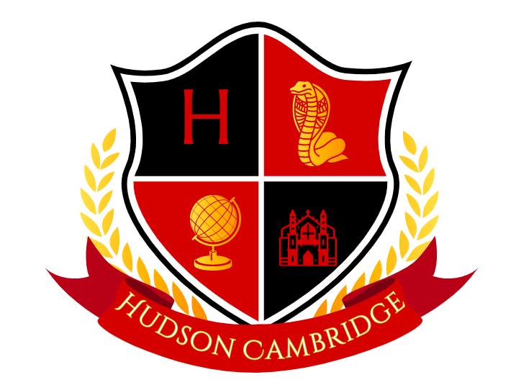
Parent Engagement Plan
2024-25

Our Mission Statement

To provide the necessary atmosphere, experiences, and tools that promote our students’ academic, social and emotional growth. Through collaboration with our families and community members, we will foster a safe, respectful and trusting environment that prepares our students for the challenges of high school, career and life.

Belief Statement

To establish Cobra Pride through a collaborative effort with our families and community members, which is dedicated to creating life-long learners, who are active participants and willing to take risks in a supportive learning environment based on the belief that all students have the potential to learn, achieve and excel.

Title I School and Families

Hudson Academy will solicit and incorporate parent feedback when making decisions regarding the use of Title I funds to enhance the learning experiences of our students.

Family Involvement Opportunities

Hudson Academy will provide our families multiple opportunities to partner, participate and engage in the learning experiences of our students. Based on feedback from our parents, HAC will provide the following opportunities:

- Parent/Family Nights (Content specific opportunities for families to learn how to better support the academic endeavors of their children)
- Parent Event Satisfaction Surveys to assist in assessing the needs of our families
- Parent Support Opportunities (PTSA, SAC, All Pro Family, Celebrations, etc)
- Parent/Teacher Conferences (Flexible scheduling provided to meet needs of families)
- Dine Out and Activity Nights
- Volunteer Opportunities
- Student/Parent Surveys

Hudson Academy
Parent Engagement Plan
2024-2025

Communication

Hudson Academy is committed to providing our families with consistent and timely information. Families will be informed of school events, volunteer opportunities, and specific student information through various modes of communication:

- SchoolConnects System
- School Website
- Social Media – Facebook, etc.
- Documents sent home with students
- Mid Quarterly and Quarterly Reports of Student Progress
- myPasco Connects Student System

Hudson Academy will partner with our families utilizing a School/Family Compact. The Compact will specify the expectations and goals for the student, family and school. These expectations will enable the student to have a meaningful experience with a focus on academic achievement.

Families are encouraged to provide feedback regarding their experiences through Satisfaction surveys after each Family event as well as during our annual needs assessment survey. In addition, the School Advisory Council will annually review and make recommendations for the Parent Involvement Plan and Family/School Compact.

The Parent Involvement Plan is made available annually to all parents. In carrying out the requirements of this plan, Hudson Academy shall provide full opportunities for the participation of parents of students, who have limited English proficiency, parents of students, who have disabilities and parents of migratory students. All information and school reports will be provided in a format, to the extent that is practical, and of the language which parents can understand.

Sincerely,

Danielle White Kevin Kolean Elizabeth Cetnor Kelly Cadle
Principal Assistant Principal Assistant Principal Assistant Principal

